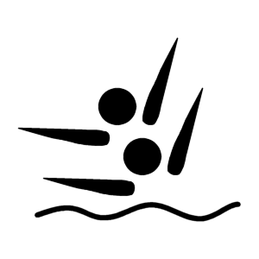

2017 MINNESOTA SYNCHRONIZED SWIMMING
STATE INVITATIONAL

This time schedule is an estimate and the competition could be running ahead or behind

THURSDAY:

7:30-7:50 Warm ups (Coaches Meeting @ 7:45)
7:50-8:10 Warm ups
8:10-8:30 Warm ups
8:35-8:40 National Anthem and Announcements
8:40-12:30 FIGURE COMPETITION
12:30-1:00 Solo Warm ups
1:00-1:45 EXTENDED SOLOS
1:45-2:35 LONG SOLOS
2:35-3:30 SHORT SOLOS
3:30-4:00 Duet Warm ups (Split into two groups)
4:00-4:50 EXTENDED DUETS
4:50-5:50 LONG DUETS
5:50-7:00 SHORT DUETS

FRIDAY:

7:30-8:10 Trio Warm ups (Split into two groups)
8:15 National Anthem and Announcements
8:20-9:05 SHORT TRIOS
9:05-10:00 LONG TRIOS
10:00-11:00 EXTENDED TRIOS
11:00-11:10 Pre-swim Team Warm ups
11:10-11:35 Short Team Warm ups
11:35-12:00 Long Team Warm ups
12:00-12:25 Extended Team Warm ups
12:30-1:35 SHORT TEAMS
1:35-2:45 LONG TEAMS
2:45-4:05 EXTENDED TEAMS
4:30 Awards Ceremony

